SILo: Sistem Informasi Logistik

Version 1.0

Revision History

|  |  |  |  |
| --- | --- | --- | --- |
| **Date** | **Version** | **Description** | **Author** |
| 01 Okt 2020 | 1.0 | Initiation | Daniel Siahaan |
|  |  |  |  |
|  |  |  |  |
|  |  |  |  |

Table of Contents

1. Insert Metadata 4

1.1 Brief Description 4

2. Flow of Events 4

2.1 Basic Flow 4

2.2 Alternative Flows 4

2.3 Exceptions 4

3. Special Requirements 4

4. Pre-Conditions 4

5. Post-Conditions 4

6. Extension Points 5

# Insert Metadata

## Brief Description

This use case describes how the cashier create a delivery note based on the order of a customer.

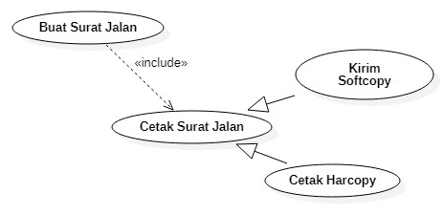

# Flow of Events

## Basic Flow

1. In the main page, Cashier clicks **Create** **Delivery Note** menu.

2. The system shows the delivery note form.

3. The cashier fills in the necessary fields, then click **Create** button.

4. The system shows a confirmation message, asking whether cashier really want to create the delivery note.

5. The casher clicks on OK button.

6. The system open the description of newly created delivery note.

7. The cashier **Print Delivery Note**.

## Alternative Flows

7a. The cashier SEND SOFTCOPY of the delivery note via email.

7a.1 The cashier clicks on **Email** button.

7a.2. The system shows a sending form.

7a.3 The cashier fill in the necessary field, and clicks the **Send** button.

7a.4 The system shows an alert that says the softcopy has been sent.

7a.5 The system shows the main page.

7b. The cashier PRINT HARDCOPY of the delivery note.

7b.1 The cashier clicks on **Print** button.

7b.2 The system shows the print dialog.

7b.3 The cashier selects necessary options, then click **Ok** button.

7b.4 The printer prints the dialog delivery note.

## Exceptions

2b.4.1a If there is one or more item unavailable, the order delivering is canceled.

2b.4.1a.1 The cashier clicks on Pending button.

2b.4.1a.2 The system changes the status to ‘pending’.

# Special Requirements

1. Only authorized and authenticated cashier may create a delivery note.
2. The list of sending form should at least have the following fields: invoice number, delivery notes number, customer name, customer email address, order date, delivery date, and status.

# Pre-Conditionss

1. A newly created delivery note should have a ‘new’ status.

# Post-Conditions

1. The delivery date of a completed delivery note should be set to current date.

# Extension Points

n.a.